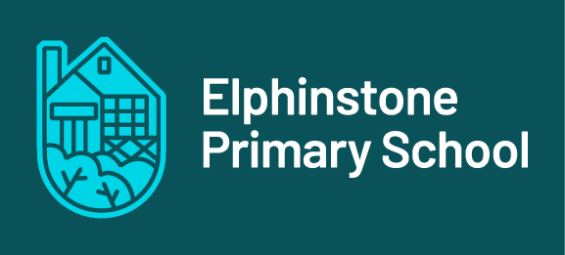

**Elphinstone Primary School**

**www.elphinstoneps.vic.edu.au 26 Wright St 03 5473 3285**

**WE CARE FOR – SELF – OTHERS – ENVIRONMENT**



# CHILD SAFE INDUCTION PACK

**Help for non-English speakers**

If you need help to understand the information in this policy please contact Elphinstone Primary School.

## **Purpose**

Thank you for your interest in volunteering at our school. The purpose of this induction pack is to ensure Elphinstone Primary School volunteers are familiar with our policies and procedures relating to child safety and understand the important role they play in maintaining and promoting the safety of our students.

Volunteers must read the suite of policies and procedures in the links below before commencing any work where children are likely to be present.

## Key messages

* Elphinstone Primary School is committed to the safety and wellbeing of all children. We want children attending our school to be safe, happy and respected.
* We are committed to creating inclusive environment where diversity is supported and students feel safe to bring their whole selves to school.
* Allegations and concerns relating to the safety and wellbeing of our school community will be treated very seriously and consistently with our policies and procedures.
* We are committed to preventing child abuse, identifying risks early and removing and reducing these risks.
* Everyone has a role to ensure children are safe – if something doesn’t feel right, speak up. If you have any concerns about any inappropriate behaviours in the school community you should speak to the Principal or Assistant Principal.

Induction materials – must read

This induction pack contains the following documents that all new volunteers must read and familiarise themselves with.

* [Elphinstone Primary School Volunteers Policy](https://www.elphinstoneps.vic.edu.au/page/171/School-Policies)
* [Elphinstone Primary School Child Safety Policy](https://www.elphinstoneps.vic.edu.au/page/169/Child-Safe-Policies)
* [Elphinstone Primary School Child Safety Responding and Reporting Obligations Policy and Procedures](https://www.elphinstoneps.vic.edu.au/page/169/Child-Safe-Policies)
* [Elphinstone Primary School Child Safety Code of Conduct](https://www.elphinstoneps.vic.edu.au/page/169/Child-Safe-Policies)
* [PROTECT: Four Critical Actions for Schools – Responding to incidents, disclosures and suspicions of child abuse](https://www.education.vic.gov.au/school/teachers/health/childprotection/Pages/report.aspx)
* [PROTECT: Identify child abuse](https://www.education.vic.gov.au/school/teachers/health/childprotection/Pages/identify.aspx)

## Contact

We value your feedback on ways we can continue to improve and strengthen our child safety approach and encourage you to contact the Principal [Brendan.Stewart@education.vic.gov.au](mailto:Brendan.Stewart@education.vic.gov.au) or our Child Safe Champion [Pamela.Rollinson@education.vic.gov.au](mailto:Pamela.Rollinson@education.vic.gov.au) with any comments or questions.